Area of Circles Practice

Directions: For each of the following problems, find the exact and approximate area. Use your calculator’s value of $π$ and round your answers to the nearest hundredth. Be sure to show all calculations!!!

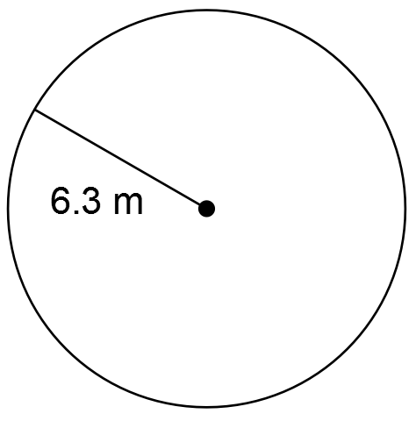 | 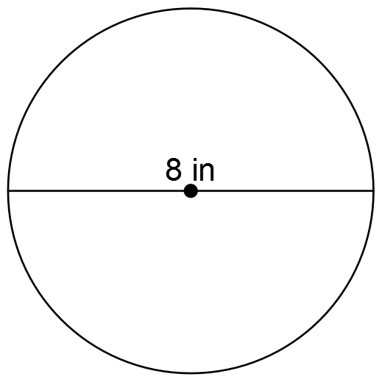

- Theo tied his dog, Flash, to a pole in the middle of the yard using a 10 foot leash. Flash dug holes in the yard everywhere his leash would allow him to go. Now, Theo has to re-seed the section of lawn that Flash destroyed. How much of the lawn does Theo have to re-seed?
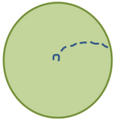
- The spray from a spinning lawn sprinkler covers a round section of the yard, which is 4.5 yards across. How much of the yard is getting watered by the sprinkler?
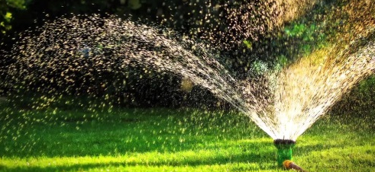
- Luigi’s Pizza in Red Bluff, California sells a pizza that is 30 inches across! There is a cheese layer that covers the entire top of the pizza (including the crust). What area is covered in cheese?
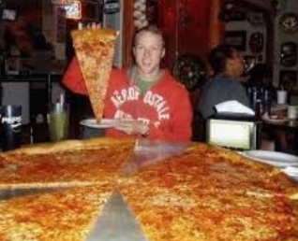

Gloverville High School decides to replace its current track with a circular one. The entire track surface will be made of rubberized asphalt, and there will be a fence around the border. The distance across the center of the track is 187 yards. How much rubberized asphalt is needed for the track? Find the exact and approximate area. Use your calculator’s value of $π$ and round your answers to the nearest hundredth. Show all work!
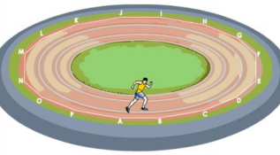

Jodie finished swimming 50 meters laps across the center of a circular swimming pool, and now she has to cover the pool with a tarp. How big is the round tarp needed to cover the pool? Find the exact and approximate area. Use your calculator’s value of $π$ and round your answers to the nearest hundredth. Show all work!
