What Do You Expect Unit Test Review

Below are three different spinners. For each spinner, decide if green is likely to be spun, unlikely to be spun, and just as likely as unlikely to be spun?

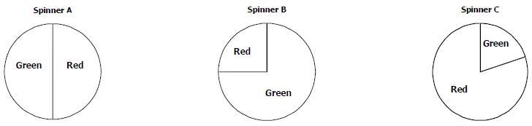

A student brought a very large jar of animal crackers to share with students in class. The student randomly chose 20 crackers from the jar, and recorded the results in the table at right.
  - What is the experimental probability of selecting a zebra?

  - Based on the experimental probability, how many zebra would you expect there to be in the jar, if there are 500 animal crackers in the jar? Show your work.

A game is played using the spinner at right.  - What is the probability of landing on a primary color (red, blue, or yellow)?  - Choose one of the options below. The chance of landing on a primary color is: | 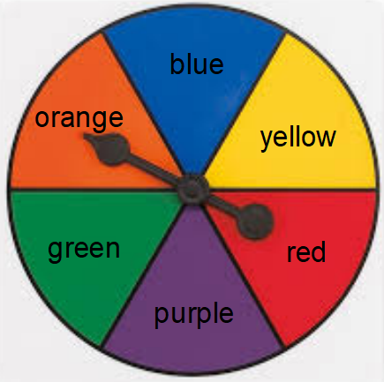
- What is the probability of landing on pink?

- Choose one of the options below. The chance of landing on pink is:

Each day, Rick eats 0, 1, 2, 3, or 4 servings of fruit and vegetables. The probabilities are in the table below.
- What is the probability Rick eats more than 1 serving of fruits and vegetables? Show your work.

- What is the probability Rick eats at least 3 servings of fruits and vegetables? Show your work

- What is the probability Rick does not eat exactly 2 servings of fruits and vegetables?
- You draw a marble from Bucket 1, and then draw a marble from Bucket 2.
- Make an area model to represent this compound event and all its possible outcomes.

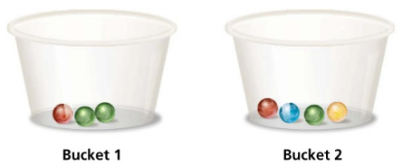
- What is the probability of drawing two green marbles?

- What is the probability of drawing at least one red marble?

- You spin each of the spinners below once, and then multiply the results.
- Make an area model to represent this compound event and all its possible outcomes.

Spinner 1 Spinner 2
- What is the probability of spinning a positive product?

- What is the probability of spinning a negative product?

- Kelly is at an ice cream shop. The options for ice cream are a vanilla, mint, or chocolate. The options for toppings are sprinkles, cookie pieces, caramel syrup, or whip cream.
- Make a tree diagram to represent the different possible combinations, and list the sample space.

- What is the probability Kelly will pick a combination of mint ice cream and cookie pieces?

- What is the probability she will pick any combination with caramel syrup?

