Story Problems with Circles (7.G.4)

- A circular race track has a diameter of 6 miles.
- How far does a car travel in one lap around the track? Use your calculator’s value of $π$. Round your answer to the nearest hundredth.

- The entire track and center pit section are being painted for an upcoming race. How much paint is needed? Use your calculator’s value of $π$. Round your answer to the nearest hundredth.

- The state fair has a merry-go-round with beautifully painted horses around the edges. The distance from the center of the merry-go-round to each painted horse is 8 feet.
- To set up the merry-go-round, the fair manager has to clear some land. How much land does the manager need to clear in order to build the merry-go-round? Use your calculator’s value of $π$. Round your answer to the nearest hundredth.

- How far does a person travel on one complete trip around the merry-go-round? Use your calculator’s value of $π$. Round your answer to the nearest hundredth.

Story Problems with Circles (7.G.4)

Definitions:
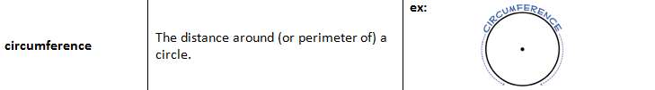
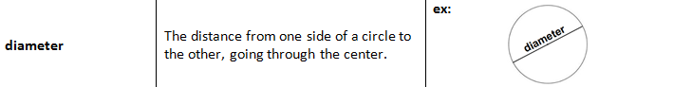
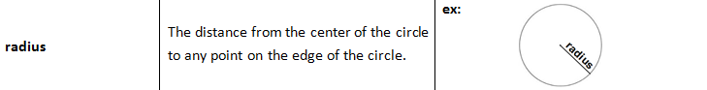
Formulas:

$$area=πr^{2}$$
$$circumference=πd=2πr$$
Examples:
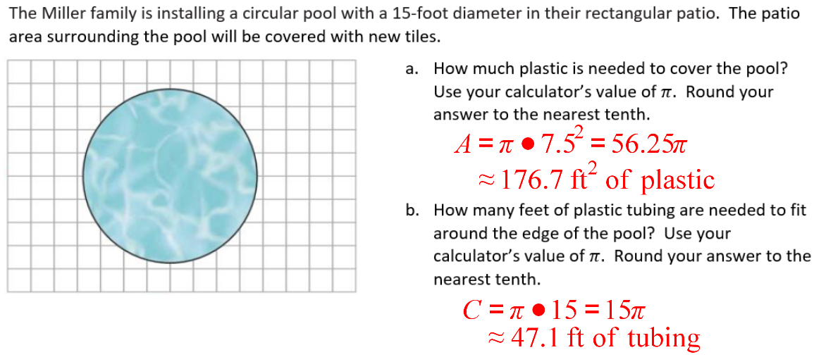

Volume and Surface Area of Composed Figures (7.G.6 three-dimensional)

- The Miter family is building a play house in the back yard, like the one shown below.
- They want to paint the outside of the playhouse green. How much paint is needed to cover the outside of the play house (but not underneath the play house)? Think about if this question is asking you to find surface area or volume. Show all work CLEARLY labeled! | 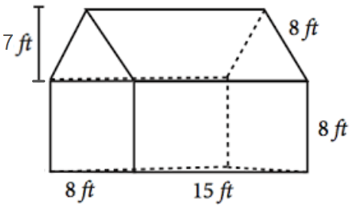

- How much space will there be inside the play house? Show all work CLEARLY labeled!

- Mark is making his own weights for working out, by building them from sheet metal and filling them with sand.
- How much sheet metal is needed for one weight? Show all work CLEARLY labeled!  - How much sand is needed for one weight? Show all work CLEARLY labeled! | 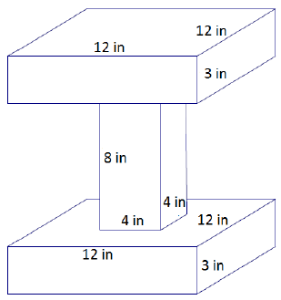

Volume and Surface Area of Composed Figures (7.G.6 three-dimensional)
Formulas:  Triangle ($b$ is base, $h$ is height):  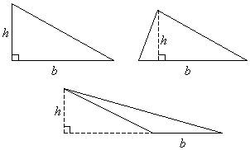  $$area=\frac{bh}{2}$$ | Square/Rectangle  ($b$ is base, $h$ is height):  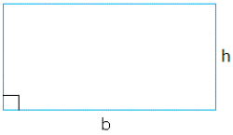  $$area=bh$$ |  | Right Prisms  ($B$ is area of the base, $h$ is height):  $$volume=Bh$$
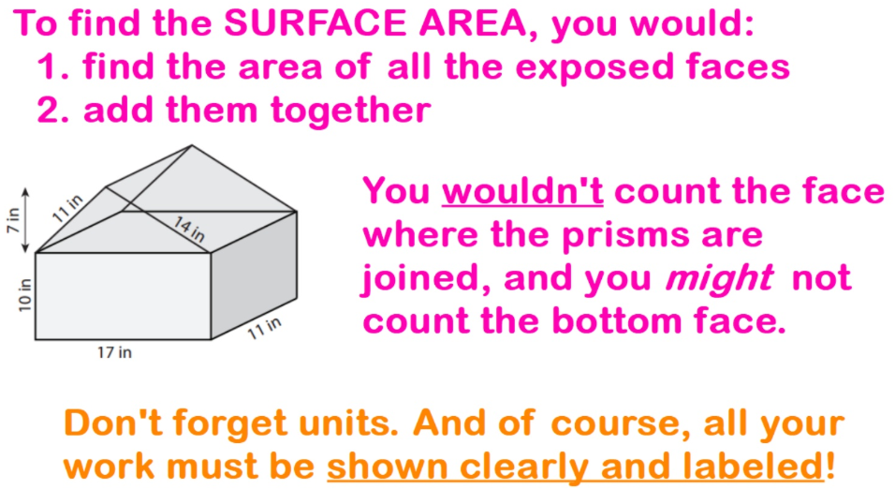 |  | 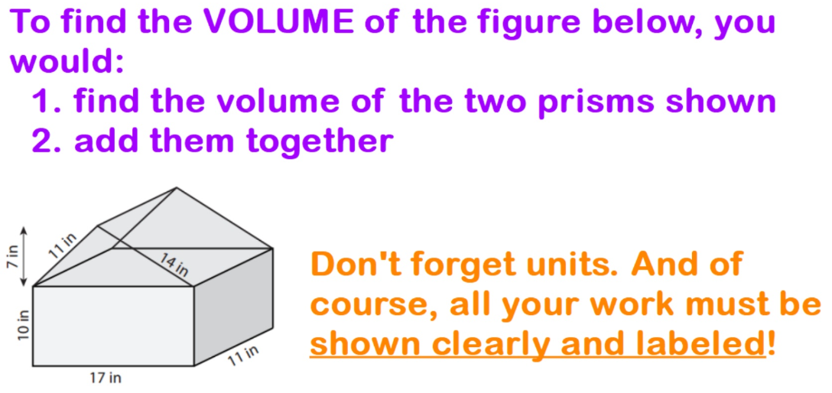
Examples:
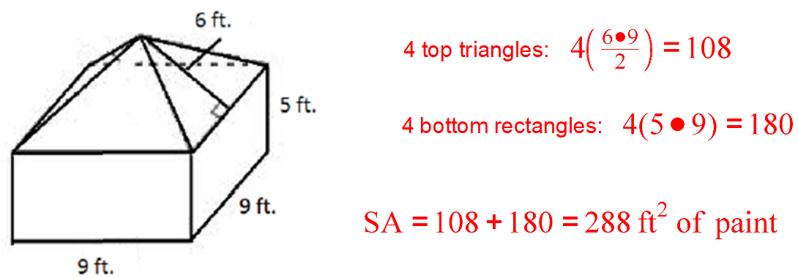
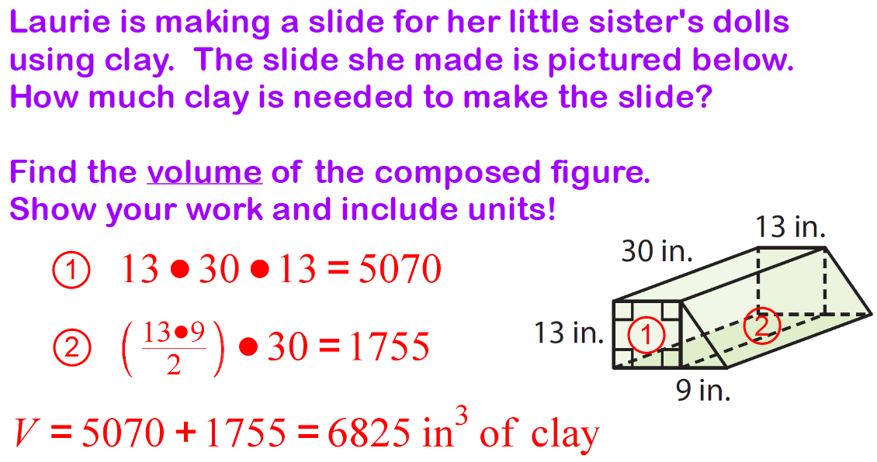

Likelihood of Events (7.SP.5)

Decide if each of the following events is impossible, unlikely, just as likely as unlikely, likely, or certain.
- A letter is randomly selected from the word CLOCK. The chance of selecting a vowel is:

- A puppy is born. The chance of the puppy being a girl is:

- You roll a number cube. The chance of rolling a 7 is:

- The spinner below is spun once. The chance of spinning a number greater than 0 is:
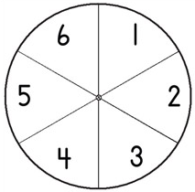

- A bag contains 15 red cubes and 85 blue cubes. The chance of selecting a blue cube is:

- A school raffle happens at lunch, and all 1000 students buy a raffle ticket. The chance of you winning the raffle is:

- A letter is randomly selected from the word LIEU. The chance of selecting a vowel is:

- A bucket contains 5 red tokens and 5 white tokens. The chance of selecting a red token is:

Likelihood of Events (7.SP.5)

Definitions:
- “impossible” – an event with a probability of 0
- “unlikely” – an event with a probability less than $\frac{1}{2}$ and greater than 0
- “just as likely as unlikely” – an event with a probability of 50% or $\frac{1}{2}$
- “likely” – an event with a probability greater than $\frac{1}{2}$ and less than 1
- “certain” – an event with a probability of 1
Examples:

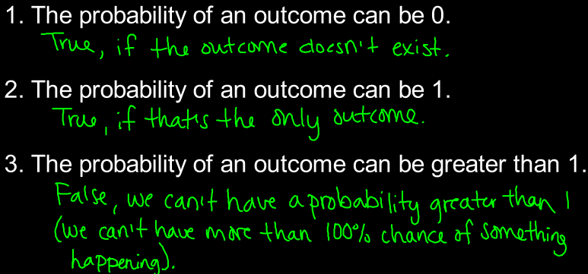

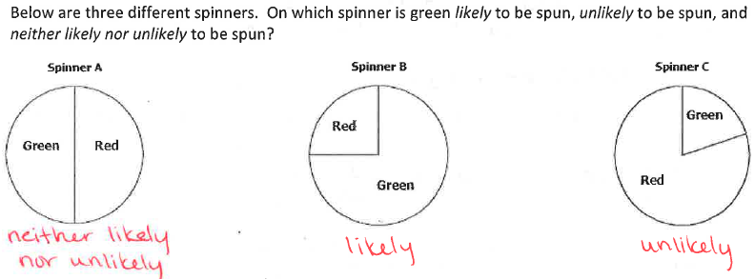

Experimental Probability and Expected Outcomes (7.SP.6)

- A student brought a very large jar of animal crackers to share with students in class. The student randomly chose 20 crackers from the jar, and recorded the results in the table below.
  - What is the experimental probability of selecting a penguin?

  - Based on the experimental probability, how many penguins would you expect there to be in the jar, if there are 500 animal crackers in the jar? Show your work.

- Julie rolls a number cube 50 times. She records the result of each roll in the table below.
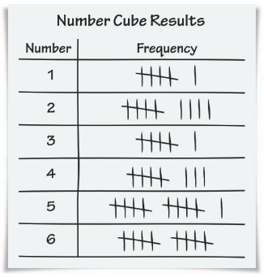 | - What is Julie’s experimental probability of rolling a prime number?
 | - Based on the experimental probability, about how many times would Julie expect to roll a prime number, if the number cube is rolled 1000 times? Show your work.

Experimental Probability and Expected Outcomes (7.SP.6)

Definition: experimental probability
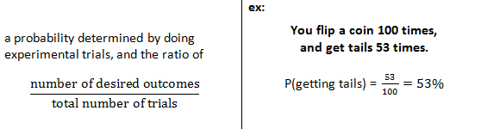
Examples:

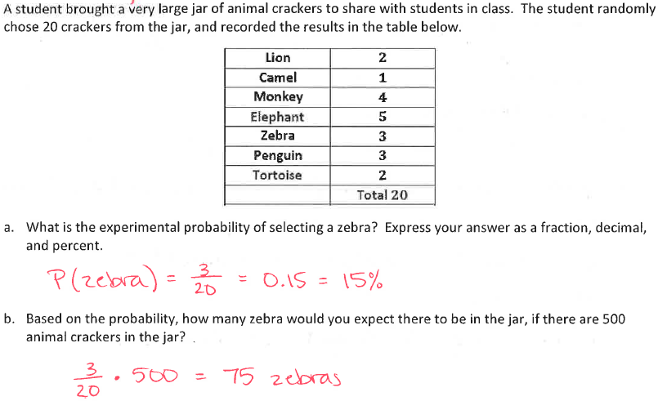

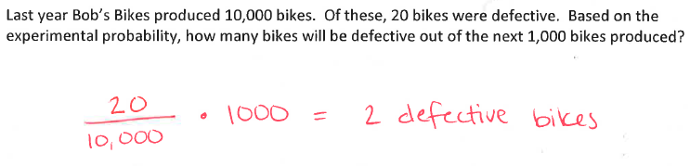

Uniform and Non-Uniform Probability (7.SP.7)

- You are playing a game that involves rolling a number cube.
- What is the probability of rolling a number greater than 2 on the number cube?

- What is the probability of rolling an even number on the number cube?

- What is the probability of rolling a number less than 3 on the number cube?

- When Jenna goes to the farmer’s market, she usually buys bananas. The number of bananas she might buy and their probabilities are shown in the table below.
- What is the probability Jenna buys at least 3 bananas? Show your work.

- What is the probability Jenna buys less than 2 bananas? Show your work.

- What is the probability Jenna does not buy exactly 4 bananas? Show your work.

- When Jenna goes to the farmer’s market, she usually buys heads of broccoli. The number of heads of broccoli she might buy and their probabilities are shown in the table below.
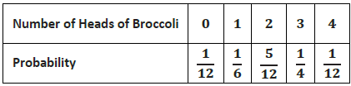
- What is the probability Jenna buys more than 1 head of broccoli? Show your work.

- What is the probability Jenna buys less than 3 heads of broccoli? Show your work.

Uniform and Non-Uniform Probability (7.SP.7)

uniform probability definition: a type of probability where all the outcomes are equally likely
Examples:
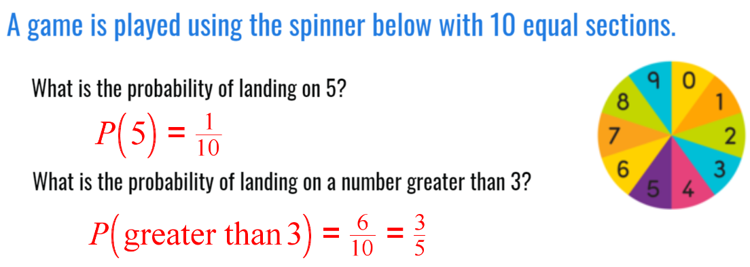

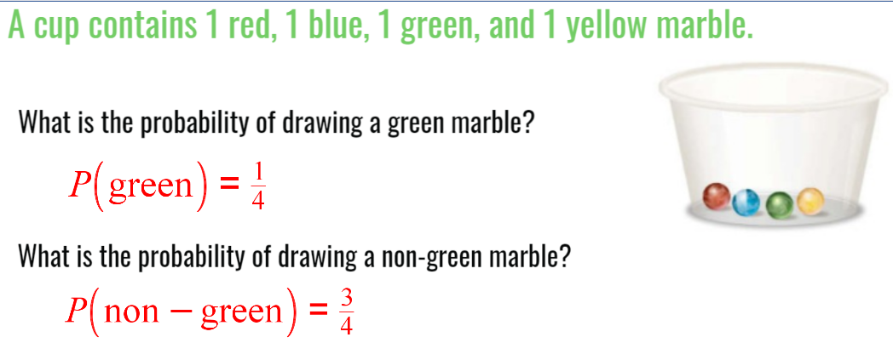
non-uniform probability definition: a type of probability where all the outcomes are NOT equally likely
Examples:
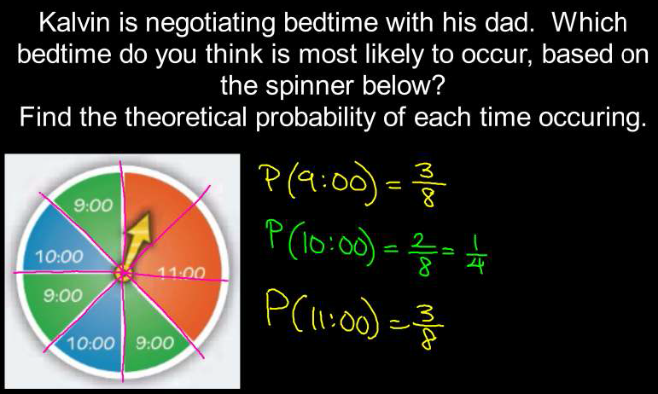
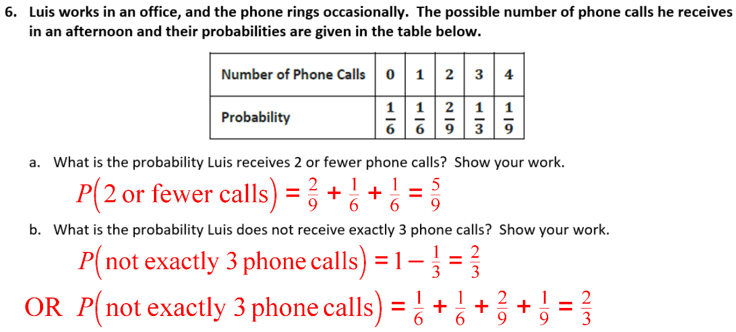

Compound Events (7.SP.8)

- You spin each of the spinners below once, and then multiply the results.
- Create an area model to represent this situation, and find all the possible outcomes.

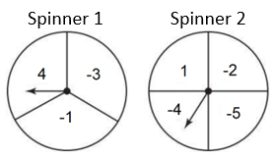

- What is the probability of spinning a positive product?

- What is the probability of spinning a negative product?

- You have a purple and a gold shirt. You also have three pairs of pants: jeans, khakis, and sweatpants.
- Make a tree diagram to represent the different possible combinations, and list the outcomes.

- What is the probability of choosing an outfit with purple shirt and sweatpants?

- What is the probability of choosing an outfit with gold shirt or jeans?

Compound Events (7.SP.8)
Steps: Area Models
- Label the top edge of the area model with the first event and possible outcomes
- Divide the model vertically into equal sections, one for each possible outcome of the first event
- Label the left edge of the area model with the second event and possible outcomes
- Divide the model horizontally into equal sections, one for each possible outcome of the second event
- Fill in each box of the model with the different possible outcomes (sample space)
Example:
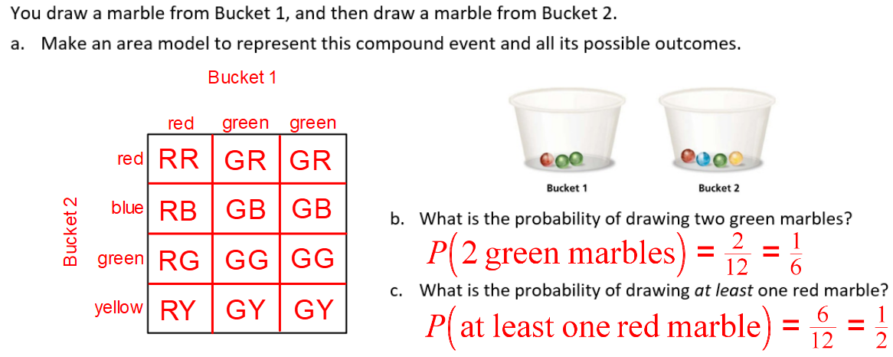

Steps: Tree Diagram
- From start, draw a branch for each possible outcome of the first event
- Label the first event above the first set of branches
- From the ends of the first branches, draw a branch for each possible outcome of the second event
- Label the second event above the first set of branches
- After the ends of the second set of branches, list the different possible outcomes (sample space)
Example:
