- 12 possible outcomes.
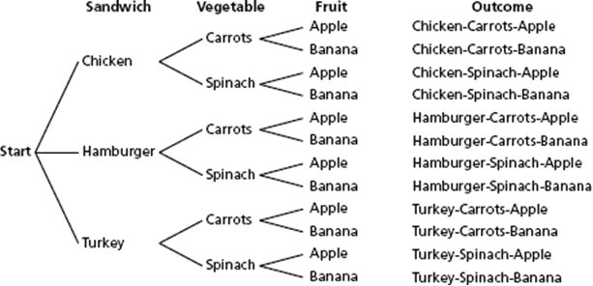
- P(favorite lunch) = $\frac{1}{12}$
- P(at least one favorite lunch item) = $\frac{10}{12}=\frac{5}{6}$

 |  | Bucket 1
 |  | red | blue | green | yellow
Bucket 2 | red | RR | BR | GR | YR
 | yellow | RY | BY | GY | YY
 | green | RG | BG | GG | YG

- P(green from Bucket 1, yellow from Bucket 2) = $\frac{1}{12}$
- P(no blue marble) = $\frac{9}{12}=\frac{3}{4}$
- P(2 blue marbles) = $\frac{0}{12}=0$

