Stretching and Shrinking Unit Test Review
Standards
7.G.1: Solve problems involving scale drawings of geometric figures, including computing actual lengths and areas from a scale drawing.
7.G.1: Reproduce a scale drawing at a different scale.
7.G.6: Solve real-world and mathematical problems involving area of two-dimensional objects composed of triangles, quadrilaterals, and other polygons.

- Below are several pairs of similar figures. In each, find the missing measurement(s). Show your thinking!!!
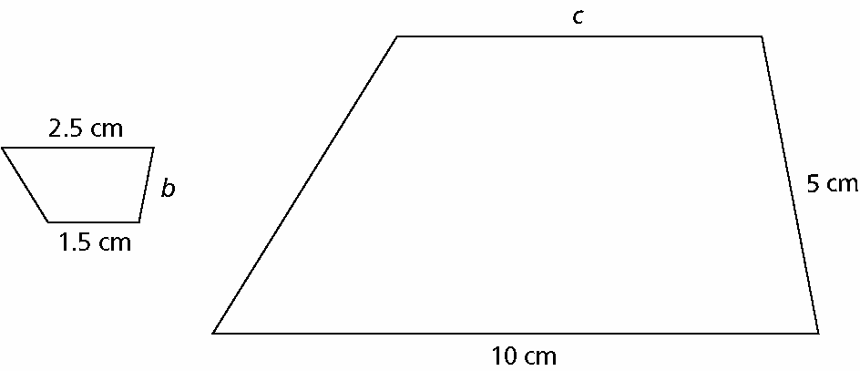
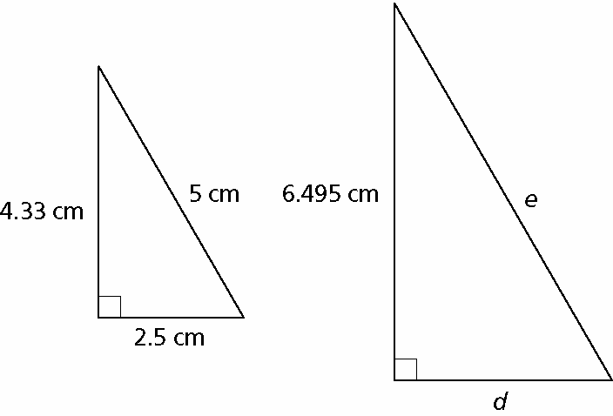

- Which rectangles below are similar? Explain why.
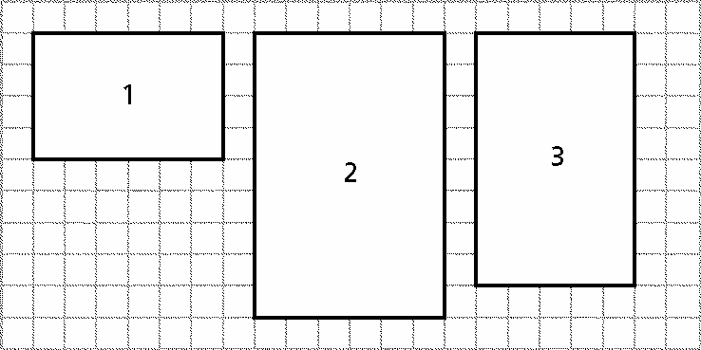
The coach took a digital photo of the new cycling team bike. She sent a 4 cm-by-6 cm photo to each team member. Suppose you want to make a 2 cm-by-3 cm copy of the original photo.
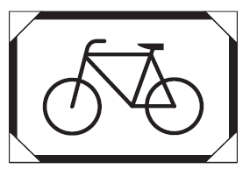
- How will the angles in the original photo compare to the corresponding angles in the smaller photo?

- How will the perimeter of the original photo compare to that of the smaller photo? Provide a numerical justification as a part of your answer.

- How will the area of the original photo compare to that of the smaller photo? Provide a numerical justification as a part of your answer.

- Rectangle A is sketched at right. Rectangle B is similar to Rectangle A. The scale factor from A to B is 3.25. Draw and label rectangle B on the grid below. | 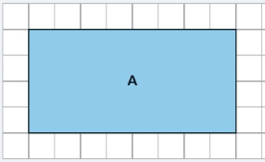
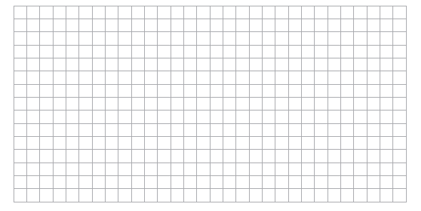

- A figure has a perimeter of 40 ft and an area of 51 ft². A similar figure is created using a scale factor of 1.5.
  - What is the perimeter of the new figure? Show your work.

  - What is the area of the new figure? Show your work.

- A figure has a perimeter of 315 yd and an area of 235 yd². A similar figure is created using a scale factor of 0.4.
- What is the perimeter of the new figure? Show your work.

- What is the area of the new figure? Show your work.

- Find the area of the figures below by using the formulas for rectangles and triangles. Show ALL work.
 | 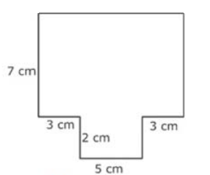
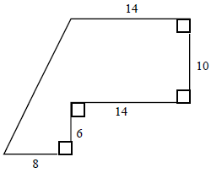 | 