Volume and Surface Area of Composed Figures

Directions: For each of the following problems, determine if you are being asked to find the surface area or the volume. Then, use what you know about the surface area and volume of prisms, to find the answers. Be sure to show all calculations!!!

- City Hall constructed a massive concrete display for the center of town, in order for citizen to decorate with murals. How much concrete is needed for the display?
- Do the employees need to find the volume or surface area, in order to answer the question?

- Calculate how much concrete is needed. Show all work!
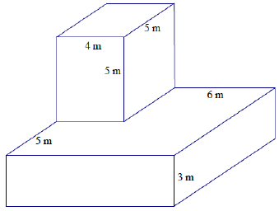
- The Jones family constructed a barn for their animals, and they want to paint the barn red (they don’t need to paint underneath the barn). How much paint is needed?
- Does the Jones family need to find the volume or surface area, in order to answer the question?

- Calculate how much paint is needed. Show all work!
